九角子
Nine Actors
为华乐团而作
for Chinese Orchestra

叶树坚
Stephen Yip

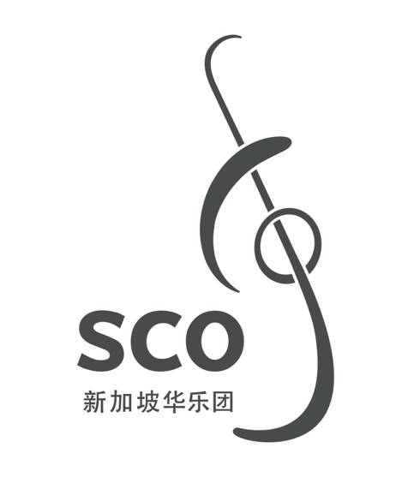

00/000
九角子
Nine Actors
为华乐团而作
for Chinese Orchestra

叶树坚
Stephen Yip
(2011)
9'

九角子
Nine Actors

ISMN

Copyright © Singapore Chinese Orchestra Co. Ltd. All rights reserved.

版权所有, 未经许可, 不得以任何形式印刷、复制、扫描或发行。
Unauthorised printing, reproduction, scanning or distribution is strictly prohibited
without the express permission of the copyright holder.

印刷于新加坡。
Printed in Singapore.

新加坡华乐团有限公司
珊顿道7号
新加坡大会堂
新加坡邮区 068810

Singapore Chinese Orchestra Co. Ltd.
7 Shenton Way
Singapore Conference Hall
Singapore 068810

网站 Website: www.sco.com.sg
电邮 Email: aa@sco.com.sg
电话 Telephone: (65) 6557 4026
传真 Fax: (65) 6557 2756
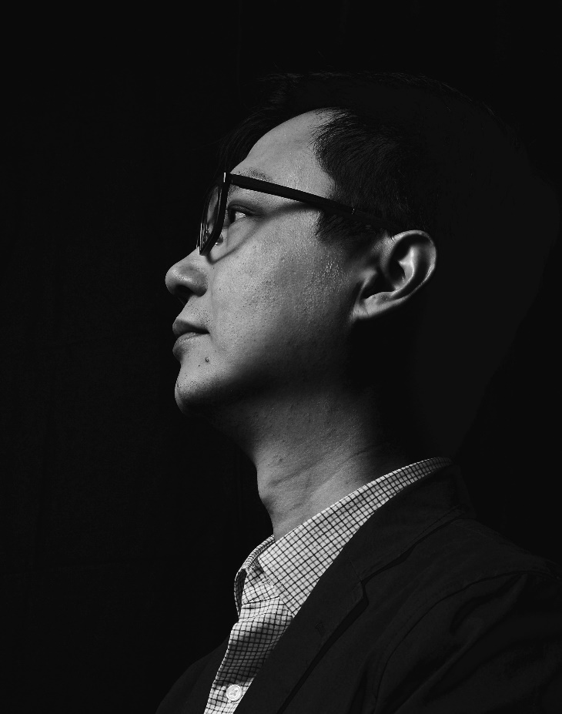
传Biography
叶树坚出生于香港，现居美国。毕业于香港演艺学院及美国赖斯大学.他曾参加Aspen音乐节、亚洲作曲家联盟、Music X、水牛城六月、IMPULS乐团学院、加州E.A.R.作曲家研讨会及捷克第十三届国际夏日节， 亦曾于佛罗里达州的亚特兰大艺术中心、内布拉斯加州的甘姆哈丁尼尔逊艺术中心及弗吉尼亚州创意艺术中心担任驻场艺术家。
他的作品曾于美国、欧洲及亚洲演出。曾获得的作曲奖项包括Salvatore Martirano 纪念国际作曲奖，新加坡中国乐队国际作曲奖，2011 台湾音乐中心TMC国际作曲大赛，Isang Yun国际作曲比赛入选奖，海法国际作曲奖、德布西三重奏音乐基金作曲比赛奖、莫利那尼四重奏的第三届国际作曲比赛、圣保罗室乐团比赛、及ALEA I作曲比赛等。他的作品经ERM-Media、PARMA、North South recording、ATMAClassical及Beauport Classical等品牌灌录发行。
叶氏曾跟多个著名乐团合作。包括香港中乐团，香港小交响乐团，香港无极乐团，新加坡中乐团，台湾十方乐集，美国Wellesley composer conference ensemble，美国north/south consonance，美国圣保罗室乐团，瑞典Curious chamber players，德国Ensemble El Perro Andaluz，韩国TIMF ensemble，卢森堡Sinfonietta，俄罗斯新音乐团等。
叶树坚是作曲家协会(SCI)及香港作曲家及作词家协会成员，现任教于侯斯顿小区学院音乐系及自由作曲家。

"Stephen Yip has an extraordinary way of creating a post-Darmstadtian modernism that incorporates his Chinese roots with a subtlety that gives us a vivid experience of the inner colors of an advanced spatial sense. It leaves us with a feeling of focused tranquility. He is a genuine voice in new music today." —Gapplegate Classical-Modern Music Review
"…. abound in colourful texture that take their cue from traditional Asian music…. and…. Yip's splendid ear and sophisticated technique stand him in good stead…."
—Gramophone Review
Born in Hong Kong and now living in U.S.A. He received his Doctor of Musical Arts (D.M.A.) at Rice University and Bachelor of Fine Arts (B.F.A.) at the Hong Kong Academy for Performing Arts. He has attended major music festivals including: Wellesley Composers Conference, Aspen Music Festival, International Summer Course for New Music Darmstadt, Asian Composers' League, ISCM World Music Days, Chinese Composers' Festival, Music X, June in Buffalo, IMPULS Ensemble Akademie, California E.A.R. Unit Composer Seminar, the 13th International Summer Program, Czech Republic, International Composers' Workshop, Luxembourg, the International Summer Course for New Music, Darmstadt, Germany, Wellesley Composers' Conference. Residencies include: the Atlantic Center for the Arts, Florida, Kimmel Harding Nelson Center for the Arts, Nebraska, Virginia Center for the Creative Arts, Yaddo Colony, NY and the MacDowell Colony, NH.
Yip's works have been performed in the United States, Canada, Costa Rica, Israel, Austria, Croatia, Czech Republic, Luxembourg, Germany, Italy, Korea, Japan, Indonesia, Hong Kong, Taiwan, Singapore, and Philippines. He has received several composition prizes, included "Earplay", "Salvatore Martirano Memorial Composition Award", "Taiwan Music Center International Composition Prize", "Robert Avalon International Prize", "Singapore International Composition Competition for Chinese Orchestra", "Haifa International Composition Prize", First International EPICMUSIC Composition Prize, Italy, International Biennial composition competition, the Debussy Trio Music Foundation, Molinari Quartet's Third International Composition Competition, the St. Paul Chamber Orchestra Emerging, the ALEA III composition Competition, the fourth NACUSA Texas Composition Competition, the International Music Prize for Excellence in Composition 2010, by the National Academy of Music, Thessaloniki, Greece, and the 2010 Alvarez Chamber Orchestra Freestyle Composition Competition, London, England .
His works have been performed by major ensembles and players such as Alarm Will Sound, Earplay New Music, Mivos String Quartet, New York New Music Ensemble, Great Noise Ensemble, North South Consonance, Brno Philharmonic Orchestra, inFLUX Duo, Windpipe Chinese Orchestra, Little Giant Chinese Orchestra, Hong Kong Chinese Orchestra, St. Paul Chamber Orchestra, Curious Chamber Players, TIMF Ensemble, Ensemble El Perro Andaluz, Hong Kong Sinfonietta, Singapore Chinese Orchestra, Avanti, Ensemble Kochi, Moscow New Music Ensemble, etc.
Yip’s works are recorded in the Albany, ERM-Media, PARMA, Capstone, North South recording, Ablaze records, ATMA Classique, and Beauport Classical labels. Yip is a member of the SCI, NACUSA, and ASCAP. Currently, he is on the music faculty at Houston Community College and works as a freelance composer.

乐曲介绍Synopsis
此作品《九角子》是取材传统福建地方戏剧“高甲戏”，实 “九角戏”。“九角戏”是由九个角色组成。作曲家尝试以九大种潮洲传统器乐演奏，如唢吶大小锣鼓，笛套，弦诗乐，细乐，潮堂乐，等，作九个音乐上的角色。曲中亦节录福建民谣《苦调》和客民谣《山子歌》作音乐素材。曲中结构以「起」，「承」，「转」，「合」，「序」，「破」，「急」作曲式。七小段一气而成把音乐上的声响和乐韵，将传统潮洲文化精作现代的启思。

Nine Actors (九角子) is based on a traditional Fujianese local drama called Gaojia Opera (高甲戏); its original title roughly translating to “Nine Actors’ Opera”, in which said opera would feature nine actors (角). To imitate the nine actors in this piece, the composer has assigned nine traditional Teochew instruments (or instrument groups) to represent these actors. These include: the suona, “drum and gong” ensemble, flute and woodwinds, strings, instrumental solos and court instrumental music, and more.
The piece is divided into seven continuous sections. The first four sections: beginning (起), undertaking (承), change (转), and togetherness (合) are written in a style of Fujianese folk tunes, while the remaining three sections: order (序), disorder (破) and hast (急), are written in Hakka style folk tunes.
Altogether, Nine Actors covers a wide range of varying tone colour, energetic rhythms and motions that reflect soundscapes that evoke traditional Teochew culture.

编制Instrumentation
梆笛 Bangdi
曲笛 Qudi
新笛 Xindi
高音笙 Gaoyin Sheng
中音笙 Zhongyin Sheng
低音笙 Diyin Sheng
高音唢吶 Gaoyin Suona
中音唢吶 Zhongyin Suona
次中音唢吶 Cizhongyin Suona
低音唢吶 Diyin Suona
管 Guan

扬琴 Yangqin
柳琴 Liuqin
琵琶 Pipa (4)*
中阮 Zhongruan
三弦 Sanxian
大阮 Daruan
古筝 Guzheng

定音鼓 Timpani
5 打击乐 Percussion
I: 大鼓 Dagu, 小鼓 Xiaogu, 排鼓 Paigu
II: 南梆子 Nanbangzi, 木鱼 Woodblocks, 排鼓 Paigu, 拍板 Clapper
III: 大低锣 Large Tam-tam, 碰铃 Pengling, 大钹 Dabo
IV: 磬 Temple Gong, 木琴 Xylophone, 大低锣 Large Tam-tam, 铝板琴 Vibraphone, 小钹 Xiaobo
V: 大钹 Dabo, 钢片琴 Glockenspiel, 小锣 Xiaoluo

高胡 Gaohu
二胡 Erhu I
二胡 Erhu II
中胡 Zhonghu
大提琴 Violoncello
低音提琴 Contrabass

* 括号内的数字为推荐演奏人数。Numbers in parenthesis indicate recommended number of players.

